For every item at the top of the product, breadcrumb should be there.

Product Name : Progue Sandals (Big Size)  
Sub Category : Men Tan sports sandal (just above category)  
Category : Mens Footware (Main Category)

Price : final Cost(450) , Orginal Cost(1500), Offer Provided(70%), Saved Cost(1000)

(show price as per quantity)

Offer Last date : show the product offer last date

Items Available Count: (show items count if count<10 if count==0 show out of stock)

Item Description : A shoe is an item of footwear intended to protect and comfort the human foot. Shoes are also used as an item of decoration and fashion. The design of shoes has varied enormously through time and from culture to culture, with **appearance** originally being tied to function.

Features of product : Show if there

Rating : 4.8, total no of ratings(2869), total no of reviews(123)

Available Offers: Show all offers ( it may be n offers)

Colors : Show all colors available for that product

Sizes : Show all sizes avaiiable for all the colors of that product (give an option to see in all measurements)

Quantity : Give an option to enter the quantity (2) (set initially 1)

Seller Details : City, State, Phone no.

Services : Show all the services provided by seller or company.

---- 1month warranty

---- return policy in 1 week

----atm card offers for that product

No of people bought the item: Show count

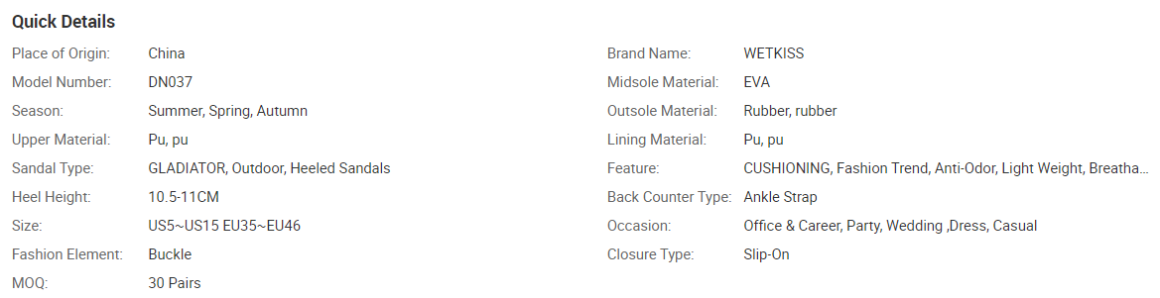

**PRODUCT IMAGE**

With the original product image, show all images for that product of same color & same size (maximum views are 6) as shown in images/views folder

On hovering the image of the product, at that place it should be zoomed. (as shown in images/zoom folder)

Rating & Reviews : (Only give option for buyers)

Provide a Button for giving rating & reviews (form should accept image also)

Show top 5 reviews with respective images(if there)( shown in images/reviews folder)